Annual General Meeting

Dover District Scout Council
Registered Charity No. 303379

Annual Report

1st September 2020
ANNUAL GENERAL MEETING
District Scout Council
TUESDAY 1st September 2020 from 7.30pm (19:30hrs) This will be conducted via Zoom, You can connect to the AGM via the Link below.
https://zoom.us/j/96037580561
Meeting ID: 960 3758 0561 Password: 546327
After registering, you will receive a confirmation email containing information about joining the meeting.
AGENDA
- Apologies for absence.
- Minutes of the 2019 AGM. (enclosed)
- Approval of the Annual Report to 31st March 2020.
- Approval of the Accounts for the year ending 31st March 2020.
- Acknowledgements.
- Approval of the nominations by the District Commissioner and the District Executive Committee of elected members to the Scout Council.
- Approval of the District Commissioner’s nomination of District Chairman.
- Election of Secretary and Treasurer.
- Election of five members of the District Executive Committee.
- Approval of the District Commissioner’s nomination of five members to the District Executive Committee.
- Appointment of Auditor.
- Elect Group Scouters to represent the District on the County Scout Council.
- District Commissioner.
- County Commissioner or representative.
- Awards.
- Any Other Business appropriate to an AGM (previously notified).
PLEASE NOTE:
- You are requested to make your nominations for election to the District Executive in writing to the District Secretary (below) with a Proposer and Seconder by 18th August 2020.
- It would be appreciated if advance notice could be given of any questions relating to the Annual Report, Accounts and Any Other Business points by 18th August 2020.
- This is a uniformed event, UNIFORM SHOULD BE WORN, PLEASE.
- There will be a briefing update from the D.C.s and District Chairman after the main AGM. Any questions you may have regarding any matters to do with Scouting/District, Please can they be submitted prior to the AGM, and we will try to answer as many as we can. Please submit your questions to your ADC to forward on to the District team.
- Please encourage parents/carers to attend

Dover District Scout Council
Annual General Meeting
10th HQ, Astor Avenue
25th September 2019
Present:
Janet Marsh (DC), John Glentworth (DC), Philip Smye-Rumsby (DC), Jeremy Wilkes, Bob Olver (3rd), Linda Iverson (ADC Cubs & CSL 15th), David Harris (10th & 17th), Jo Parness (5th), Elizabeth Marsh (18th), Rebecca Simcox (Parent Representative), Gary Green (4th Dover Explorers).

Apologies:
Rita Sherlock (DC), Mark Parness, Abbi Parness (Youth Commissioner), Dave McRoberts (13th GSL), Richard Worrell (15th), Hannah Golding (CSL 17th), Paul Golding (17th).

Minutes of 16th July 2018:
Distributed and Approved

Matters Arising:
None

District Executive Committee Report:
Distributed and Approved

District Commissioners & Section Reports:
Reports given by
Janet Marsh – Training and Development
This has been again a challenging year to consolidate on the progress that we made last year.

Appointment’s Committee
Unfortunately, we have a number of leaders who need to go through the committee and Jeremy is co-ordinating the dates of the committee. Unfortunately, our appointment’s secretary work commitments mean that she is unable to continue in her role and so we will need to recruit into the post.
The committee will then move onto leaders reviews, linking these in with their DBS and camping permits.

Training
As part of the appointments process for all new leaders, they have been given their personal learning plan alongside their training pack, containing information regarding the district and how to access their training and the name of their training advisor. I hope that this will enable leaders to access and complete their training more easily and within a more defined timeline.
I have also commenced quarterly training sessions for first aid and safeguarding in order to ensure that our leaders are up to date and can easily access their mandatory training.
I have also set up regular training surgeries to review leaders’ training and to validate those who have undertaken training. So far this year four leaders have completed their training and I have recommended then for their wood badge. It was so fantastic to have set some of these leaders off on their training and then be able to sign off their training. It was a proud moment for us all.
I look forward to continuing to work with all the leaders within the district and moving training and appointments forward.

Abbi Parness – Youth Commissioner
First of all I must apologise for not being present, but unfortunately I am working.
Over the last year as Youth Commissioner I have seen so much happen in and for the Dover District Scouts.
We had the Porch Light sleep out last November which all the young people I spoke to said they wanted to do again, not that we wanted to show homelessness as being fun.
I’ve visited a few groups over the last year, not as often as I would have like but I got to see the youth hold a debate that was organised by the Young Leaders. If that is not what Young Leader stands for then I do not know what else, it could mean.
I have been able to watch as everyone helped at events like the Easter Egg hunt for the World Scout Jamboree participants, and the Western Heights car parking.
Some of you, well most of you will know about the Halloween Camp I am organising for the youth or at least I am doing the fun bits, I would really appreciate the support from everyone.
In the last year I have taken on a full time job as some of you know which takes a lot of my evenings up now, so I have created a team of Young Adults who are already in the groups to help keep scouting youth led.
I would like to say thank you to them as they are great and will hopefully look to take on the role once I get to old.

Linda Iverson – ADC Cubs
During the year Cub sections have taken part in the St George’s Day Parade, Remembrance Day, and the Carol Service.
Cubs had a Sixer & Seconder camp in May 2018 at Kingsdown; a very wet weekend but went well.
We also put on a Fun Day at Samphire Hoe, Athlete Plus Badge Day, and Cub Challenge. A photography badge day was held in March 2019 and was great success.
We have eight cub section in the district. At least three take part in most of the events.

Philip Smye-Rumsby – GSLs and District Groups’ Summary
I have regularly visited most of the town groups throughout the year. This does however exclude the 4th, 5th, and 18th. The 4th and 5th are covered by an acting GSL from the District Team, with the 18th having an incumbent GSL, all be it being a District Commissioner.
Currently I am acting as GSL for the 10th, 15th, and 17th, which is of concern, but as from September will be endeavouring to push hard to have parents/guardians to take on this and other positions. There is a letter that is currently being composed that will be sent out, but I have emphasised the need that this is a physical document and not an email but given or posted directly to the parents and guardians. The letter will be reviewed prior to being sent.
The district team are fully aware of the lack of GSLs, and have been discussing the possibilities of ‘Super GSLs’ covering more than one group in the district.

10th:
This group only has Beavers and Cubs, and due to lack of leaders the 17th and a YL are providing additional support. There is currently no prospect of a Scout section being put in place. There is a new Beaver Leader who was previously with the 17th. She is holding a joint camp with the 17th in the later part of September to count towards her camp permit.
Their lease from Dover District Council for their HQ is currently with a solicitor.
I have asked them to set a date for their AGM.

13th:
They have a GSL and a new executive team. Each section has a leader, with the beavers and cubs having assistant leaders, however the ABSL is currently out of action. The main problem is that the beaver and scout leaders are both shift workers, again this issue would be alleviated with assistants and would take pressure off them having to find cover. YLs help with the beaver and scout sections.

15th:
After the resignation of the current GSL, I have only recently taken up the role of acting GSL. To date I have not been informed of any significant problems, and it is one of the stronger groups in the district. The CSL is undertaking the management at present; in effect GSL but does not wish to take up the post.

17th:
The group requires a new secretary, and the treasurer has expressed a wish to stand down. The remaining executive members are long standing. The SL has an erratic work schedule which can and does cause problems. There are leader training needs that need addressing, which the district team are aware of.
Their lease from Dover District Council for their HQ is currently with a solicitor.

Explorer Unit 2:
This group is currently being supported by the AESL. They provide YLs to the district. Several are undertaking their DofE. A joint gliding camp was held with the other district explorer groups at Waldershare Park in mid-June. They have also recently helped at the Kent County Show.

All leaders, assistants, helpers, and executive teams work hard for their respective and other groups, and the District Team thank them for their efforts.

Special Needs:
At present I have not been informed of any members requiring intervention.

and Approved

Explorer Scout Units Committees’ Reports:
DC not available. A verbal report was given by Gary Green (4th Unit) and Philip Smye-Rumsby (2nd Unit)

Accounts:
The treasurer was unfortunately working. Jo Parness reported that the accounts were not complete as he was waiting for the accounts from the 4th Explorer Unit. Philip Smye-Rumsby gave an apology due to workload, but would send them in shortly.

Nominations for members to the District Council:
None put forward

Nominations for District Chairperson:
None put forward

Nominations for members to the District Executive:
Jo Parness & Linda Iverson agreed to continue their membership.

Nominations for District Secretary:
No nominations

Nominations for District Treasurer:
No nominations. Jo Parness informed meeting that Mark is intending to step down.

Nominations for Scouters to County Scout Council:
No nominations

Appointment of an independent examiner or auditor:
Current person to be approached

County Commissioner:
Not Present

Awards:
Proposal for Jackie Humphries formerly of the 17th for more than 30 years of service. She has had to step down due to her health.

AOB:
None

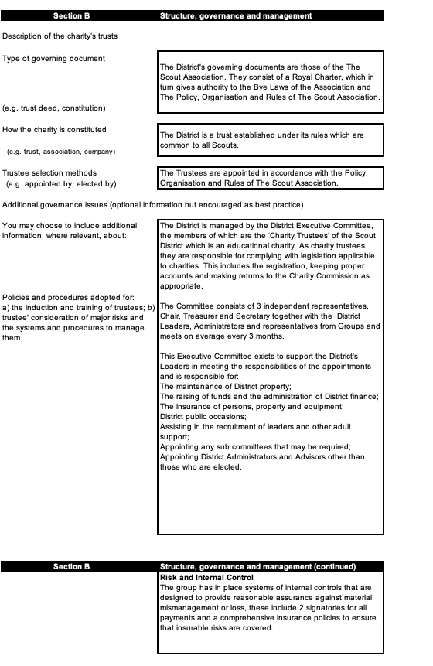

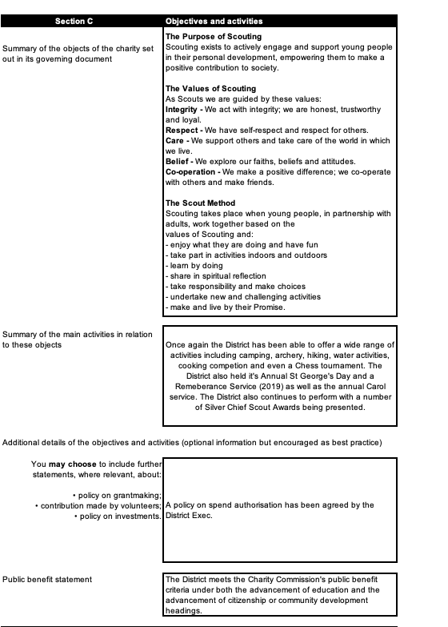
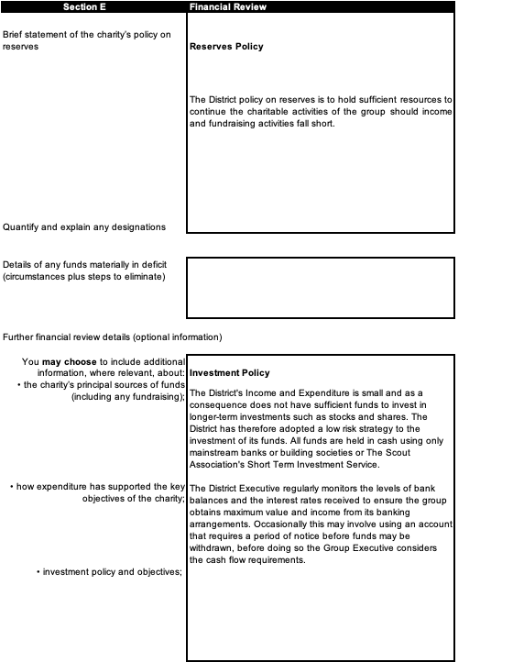

 |  | Section F |  |  | Other Optional Information
Plans for future periods (details of any significant activities planned to achieve them) |  |  |  |  | The district will continue to provide activities for the young people and fundraising activities for these.
 |  | Section G |  |  | Declaration
The trustees declare that they have approved the trustees’ report above
Signed on behalf of the charity’s trustees
 |  | Signature(s)
 |  | Full name(s) |  |  | Paul Betts
Position (eg Secretary, Chair) |  |  |  |  |  | Chair
 |  | Date |  | 1 | 8 | 0 | 8 | 2 | 0

Section Reports to District AGM 2020

District Commissioners Report

Please forgive me for stating the obvious but, the past year has been a strange and difficult one for all in Scouting. When Covid-19 raised its ugly head at the beginning of the year, no one would have predicted the repercussions of coronavirus. Face to face Scouting stopped and all District events stopped and a new style of Scouting developed. Online Scouting became the normal. The District team would like to take this opportunity to say a massive thank you to those leaders who have stepped up to the challenge of organising and running on-line meetings.

Even with the challenges posed by the pandemic, Beavers, Cubs and Scouts have still managed some activities which are detailed below. Thank you to the Jo Parness, Linda Iverson and Dave McRoberts and their teams on continually putting on a varied and exciting program for our young people. I had the pleasure during the lockdown of presenting 2 Silver Chief Scout awards, congregations to Ryley and Jack.

Everyone in the District now has to come together to meet the next challenge facing all of us, that is getting back to face-to-face scouting and bringing back all our young people, I’m confident that all the leaders within Dover District are up for this challenge and we will be moving the District to new challenges and achievements.

Beavers

I took up the role of ADC Beavers on 4th February this year and Ann-Marie Hirst took up the role of District Beaver Leader.

We held a Beaver Scout leaders meeting on 26th February where we put together a plan of events for the District.

I visited 17th and 13th and, of course, 5th Beaver Scout meetings but then Lockdown interfered!
This has put a stop to the events we had planned and we will have to wait and see when we will be able to put District events on again.

Jo Parness

Cubs

Cubs attended the St. Georges Day Parade on the seafront in April. Good turnout.

We had a District Hike from Rowallan Hall up and around Hougham area and back. Drinks and Hot dogs were served when they came back.

Archery sessions at Waldershire Park proved to be extremely popular. We had so many we had to split them into morning and afternoon sessions.

Power boat sessions were taken by two packs. They had great fun and earned some badges.

District camp in Kearsney during September was enjoyed. We put on bases, had campfires. Two outings on the Saturday. Some went to the Transport museum and the others went power boating in the harbour.

In October we had the Cub Challenge. Quite well attended. All had a good time.

There were lots of Cubs at the Remembrance Day parade.

District Carol service. A few Cubs attended but not many.

March 2020. We held a Science badge day in Rowallan Hall. It went very well with over 30 Cubs attending.

Linda Iverson

Scouts
I returned from a period away from Dover in late Autumn last year, and set about with the Scout leaders drawing up an exciting and varied program of activities throughout 2020. Alas, after a couple of events the world came to a grinding halt!
We did manage to put on the district chess competition, with 9 scouts pitting their wits and combat skills against each other – a very high level of skill and aptitude was on display!
We also held the Ready Steady Cook competition, graciously hosted by the 18th. The food produced was superb, with fine examples of time management and team working on display.
But due to Covid, that is all we have managed to complete. Once face to face scouting is resumed, we will review the program and modify it to the end of the year. Hopefully I will be able to have a greater presence in the district too, getting out to see the groups in action.
Dave McRoberts
Report prepared by John Glentworth and District ADC’s
Youth Commissioner Report 2019-2020
I’m going to start by apologising as I’m on nights which is why I’m not actually reading this, I am listening though.
Halloween camp happened last November, although that feels like a lifetime ago, I had over 100 young people participate and so many leaders and parents help out so I’d like to once again extend my thanks for all your help and support, I quite literally would have been stuck without it. While planning Halloween camp I consulted with young people to try to make it as youth shaped as I possibly could and all the feedback I’ve had from young people after has been positive so I believe that they had a good time.

I visited multiple sections pre march to help out and to make sure all the young people were having their input and enjoying their scouting, I can honestly say that the leaders in the district make my role so easy because they all take their young people’s opinions into account when planning activities, so thank you.

I went to the Shelter box training back in march so that I can help to plan the shelter box event once we know what life will be like post virtual scouting and try to make sure its as young people oriented as possible.

The last in person Youth Commissioner visit was to 13th beavers when they learnt about how to wash your hands and what makes a badge blanket, that was the evening we were told to cease f2f scouting on the 16th march 2020. Since then I have put out a few Youth Commissioner Challenges for the young people to try, which also go towards some of their badges! Been on quite a few zoom calls, I’ve been able to virtually see George from the 3rd take up cycling to raise money for their group (which I think is absolutely amazing) and just see how many of the young people have done scouting at home. I wish I could say ill pop in and see you in September but I probably won’t get to be able to do that until 2021 at the earliest. If your young people have any ideas on what they want the next youth commissioner challenges to be then let me know, I’d love their input!

Abby

Appointments and Training
Since being back in post, I have been presented with many challenges, mostly unfortunately, with regard to COVID.
At the beginning of March, we held a Development morning run by the County team, which was well attended by members of the District. We were able to discuss plans to develop our District and it was good to hear Leaders views and contributions. It was a highly enjoyable morning and a good way for John and myself to spend time with the Leaders.
At the present time, there are 22 volunteers waiting to be seen by the Appointments Committee. Due to COVID we have been unable to undertake face to face interviews and so I will be setting up virtual committee meetings in order to complete the appointments process.
My thanks to Jeremy Wilkes and the Appointment’s Committee members for their work. We are always looking for new members so if anyone is interested in sitting on the committee please let me know.
We are still in need of an Appointments Secretary so again if you are aware of any volunteers, please let me know.
We will then be moving on to Leaders reviews which form one of the responsibilities of the Appointments committee. We plan to meet at least once a quarter to ensure that appointments are dealt with efficiently and effectively.
As part of the appointments process for all new leaders, they have been given their personal learning plan alongside their training pack, containing information regarding the District and how to access their training and the name of their Training Advisor. I hope that this will enable leaders to access and complete their training more easily and within a more defined time line.
Training has also been affected by the COVID crisis, although County have put online training which a number of Leaders have attended. I have reviewed the training needs of the District and contacted those who are out of date with training.
I have also held regular training surgeries, so that leaders can come and discuss training and have modules validated. I hope to restart these once the COVID threat has passed.
In the future, I look forward to working with all the Leaders within the District and moving the training and appointments forward by clearing the back log of leaders who need to be processed through the appointments committee.
from Janet Marsh

